Expression vectors
The expression vectors are vectors which act as vehicles for DNA insert and also allow the DNA insert to be expressed efficiently. These may be plasmids or viruses. The expression vectors are also known as expression constructs.
The expression vectors are genetically engineered for the introduction of genes into the target cells. In addition to the gene of interest, these expression constructs also contain regulatory elements like enhancers and promoters so that efficient transcription of the gene of interest occurs.
The simplest expression constructs are also known as transcription vectors; only because they allow transcription of the cloned foreign gene and not its translation. The vectors which facilitate both transcription and translation of the cloned foreign gene are known as protein expression vectors. These protein expression constructs also lead to the production of recombinant protein.
Now, for transcription and translation, a promoter and a termination sequence are a must. Transcription initiates at the promoter and ends at the termination site.
The promoters of expression vectors must have on/off switches. These switches help in the regulation of production of the gene product. Excessive amounts of product of the gene of interest can be toxic for the cell.
A common promoter utilized in the expression constructs is the mutant version of the lac promoter, lacUV. The lacUV promoter initiates a high level of transcription under induced conditions. Moreover, in some expression vectors, a ribosomal binding site is present upstream to the start codon.
The ribosomal binding site facilitates the efficient translation of the cloned foreign gene.
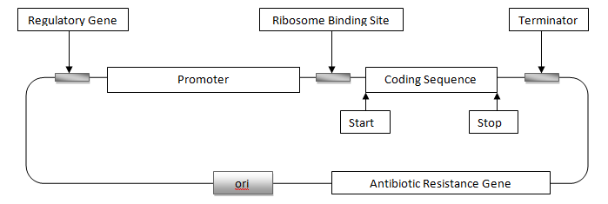
Figure: schematic diagram of an expression vector
- Once the expression construct is inside the host cell, the protein encoded by the gene of interest is produced by the transcription. Thereafter, it utilizes the translation machinery and ribosomal complexes of the host organism.

- Frequently, the plasmid is genetically engineered to contain regulatory elements like enhancers and promoters. These regulator sequences aid in efficient transcription of the gene of interest.

- Expression vectors are extensively used as tools which help in the production of mRNAs and, in turn, stable proteins. They are of much interest in biotechnology and molecular biology for the production of proteins like insulin. Insulin is the chief ingredient in the treatment of the complex disease, Diabetes.

- When the protein product is expressed, it is to be then purified. The purification of a protein poses a challenge since the protein of interest, whose gene is carried on the expression vector, is to be purified independently of the proteins of the host organism. To make the process of purification simpler, the gene of interest carried on the expression vector should always have a ‘tag’. This tag can be any marker peptide or histidine (His tag).

- Expression vectors are considerably exploited in techniques like site-directed mutagenesis. Cloning vectors introduce the gene of interest into a plasmid which in turn replicates in bacteria. These cloning vectors need not necessarily result in the expression of a protein.

Therefore, expression vectors must have the following signals:
- The promoter, which marks the point at which transcription of the gene should start. In E. coli, the promoter is recognised by the σ subunit of the transcribing enzyme RNA polymerase.
- The terminator, which marks the point at the end of the gene where transcription should stop. A terminator is usually a nucleotide sequence that can base pair with itself to form a stem-loop structure.
- The ribosome binding site, a short nucleotide sequence recognised by the ribosome at the point at which it should attach to the mRNA molecule

In most vectors these expression signals form a cassette, so called because the foreign gene is inserted into a unique restriction site present in the middle of the expression signal cluster.

